Intranasal Naloxone – Frequently Asked Questions

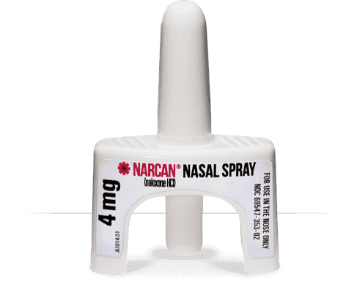
What is Intranasal Naloxone?
- Naloxone is a medication that can temporarily reverse the effects of an overdose related to opioids. This medication can be delivered through an injection or through the nasal passage.
- Intranasal naloxone is a concentrated 4mg formulation which is administered directly into the nose of the person experiencing an overdose. This formulation is more concentrated than injectable naloxone and similarly has no effect on someone who is not using opioids.
- Accessibility to injectable naloxone has improved in Alberta since naloxone was declared an unscheduled drug and became available without prescription. Intranasal naloxone through the Non-Insured Health Benefits (NIHB) program requires a prescription or recommendation from a pharmacist and proof of First Nations status.
What are the advantages to intranasal naloxone?
- Intranasal naloxone is ready to use, can be easily administered with less formal training and is a more concentrated dose of naloxone. Intranasal naloxone is an open benefit under the NIHB program.
- Intranasal naloxone can be easier to use as it does not require using a needle on a client and may be of benefit for those with decreased dexterity.
- Contents that are eligible for inclusion under NIHB are two 4mg naloxone nasal spray devices, one breathing mask, one pair of gloves and a carrying case.
- The requesting client does not have to specify who the kit is for, but it will be billed to NIHB under the name of the client.
What are the disadvantages to intranasal naloxone?
- The Alberta Health Services Community Based Naloxone program uses the injectable formulation of naloxone and provides training, support and evaluation.
- Intranasal naloxone is not included in this program and has a higher price point than injectable naloxone. Intranasal naloxone kits contain two sprays however each spray is a single dose and can only be accessed through a pharmacy under NIHB coverage. This access requires a client’s proof of First Nations status, whereas the provincial program provides injectable naloxone without any identifier or prescription required.
- Injectable naloxone can also be provided by the province to organizations and health centres in bulk. Intranasal naloxone through NIHB can be provided to the same client more than once but is intended for personal use and is not intended for distribution.
What is the role of the First Nations and Inuit Health Branch (FNIHB)?
- FNIHB is monitoring the use of intranasal naloxone through NIHB.
- FNIHB continues to support the AHS Community Based Naloxone program.
- In remote First Nations communities in Alberta, Intranasal naloxone has been previously distributed.
- FNIHB has health professional and other supports for communities looking to expand their overdose prevention programs.
Can Health Centres or other organizations give intranasal naloxone to staff to use?
- Intranasal naloxone can be prescribed by a nurse practitioner or a physician or recommended by a pharmacist for individuals at risk of opioid overdose or individuals who know someone at risk.
- It can also be ordered through the manufacturer at www.narcan.com. Intranasal naloxone through the NIHB program is intended for personal use.
Is there training available?
- Training videos are available through the NARCAN website. While intranasal naloxone temporarily reverses the effects of an overdose, emergency medical care is still required. Overdose response protocols should follow those recommended by Alberta Health Services which outlines the SAVE ME steps (pictured below).

